/\*

Ashok Rathod

Combine data from multiple sources

5.7.19

Lab work 2 document for join 4 table\*/

Create a join using 4 tables in AdventureWorks database. Explain what the join is doing and post it to the Group.

Find the Year to Date sale of Products by country using JOINS

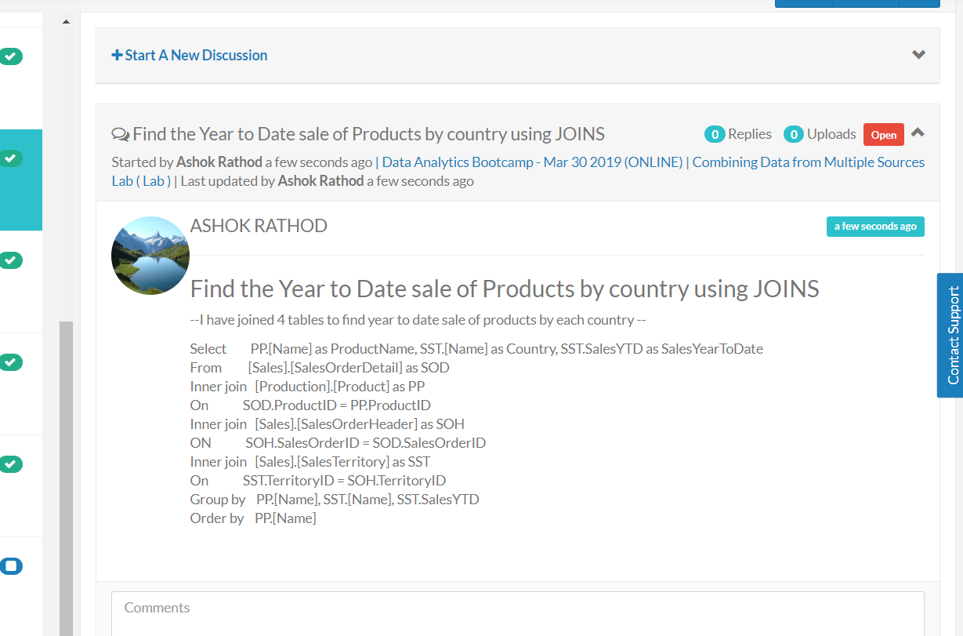

Group Exercise:

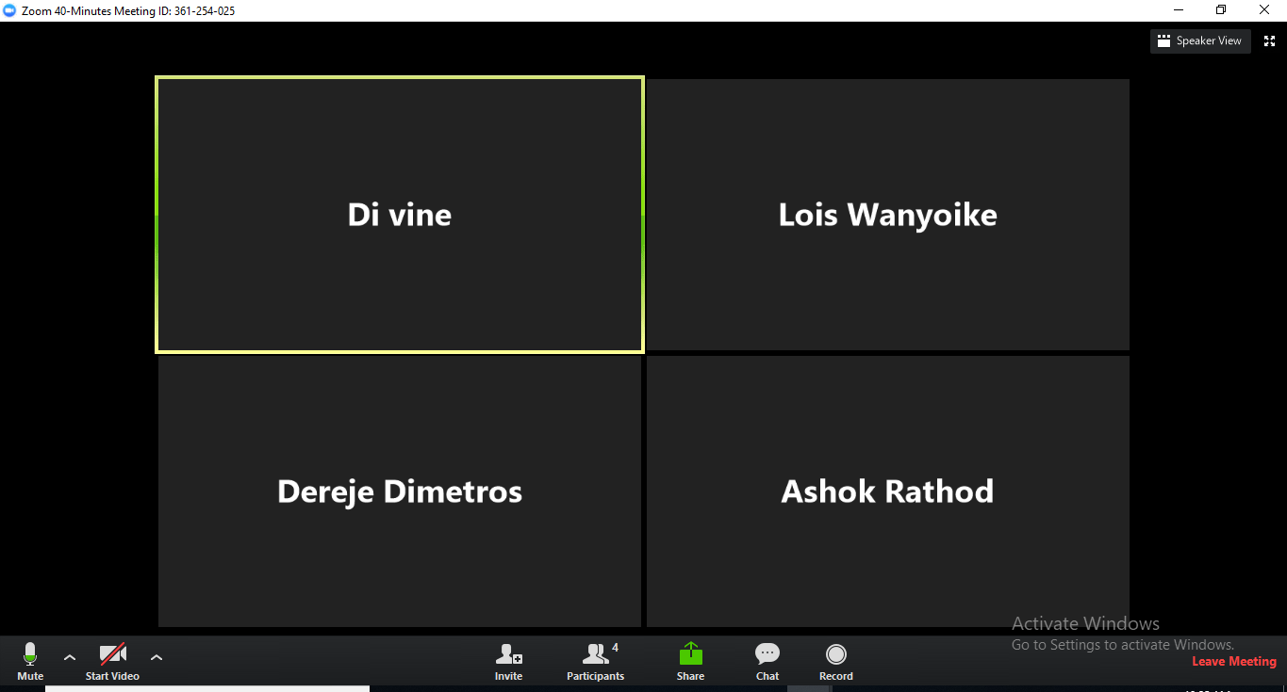

Leader of the Group : Dereje Dimetros

Di Vine : Combining Data from Multiple Sources - Joins

Ashok : Combining Data from Multiple Sources - Joins

Lois : Combining Data from Multiple Sources - Joins

Dereje : Combining Data from Multiple Sources - Joins